**Spring MVC**

Spring MVC is a framework for building web applications in Java and is based on Model View Control. It leverages features of Spring Core (IOC, DI).

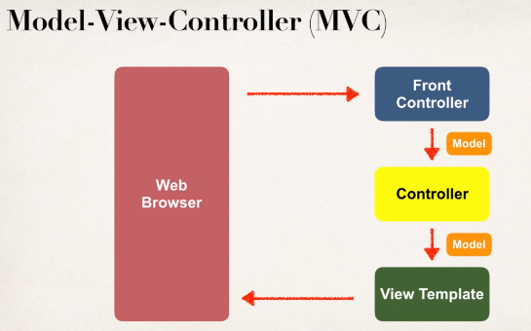

Components of Spring MVC application:

* A set of webpages to layout UI Components
* A collection of Spring beans
* Spring configuration (Annotations/XML/Java)

